Top-Down Design

Group Practice Assignment

Kole Frazier

Physics 2300

**Problem**

A program is needed to predict the outcome of satellite collisions.

**Inputs**

Mass and altitude of each satellite.

**Outputs**

Velocity and whether the satellites continue to orbit after the collision.

**Algorithm Design**

Assuming the satellites are on course to collide in a perfectly inelastic manner and that they are travelling at the same altitude, the only information we need to know is the mass and velocities of the two satellites before they collide.

After collecting this information, we can use universal constants – such as the force of gravity and the Earth’s mass and radius – to determine the altitude height.

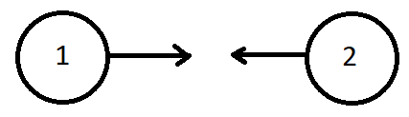

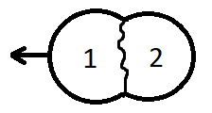

Using these constants and the information given by the person using this program, it can be determined what happens after the collision. This information will contain the post-collision velocity of the mass along with whether the mass will maintain its altitude or crash to the Earth.

We determined the following to represent the final velocity and height of the post-collision mass:

Final Velocity (Vf) =

Final Height (Hf) = =

**Sequence Chart**

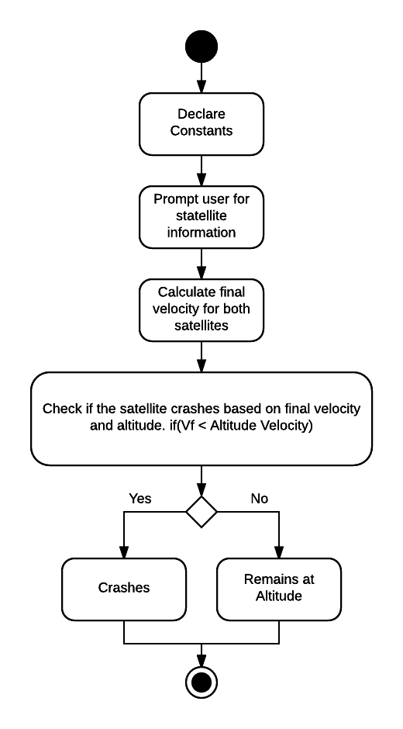

**Pseudo Code**

#Import math libraries

#Declare constant values

#Gravitational Constant, Earth's Mass and Radius

#Prompt user for satellite information

#Calculate final velocity for the post collision mass

#Check if the object will crash or remain orbiting

#Display result for user